

PROGRAMMING FUNDAMENTALS

LAB 5



Question 1:

Write a program in which user continuously enters integer numbers, the program stops

when the user enters any number other than the numbers between 200 and 400. Finally, it

displays the sum of all the numbers entered by the user.

Code:

#include<stdio.h>

int main()

{

int n=0,s=0;

do

{

printf("Enter the number: ");

scanf("%d",&n);

s=s+n;

}while(n>200&&n<400);

printf("The sum is: %d",s);

}

Output:

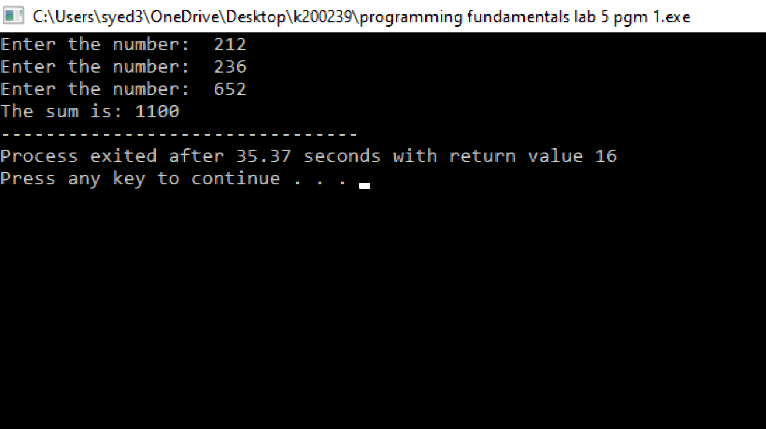

Question 2:

Write a program in which user continuously enters a character, the program stops when the

user enters ‘z’ character and finally displays the number of characters entered.

Code:

#include<stdio.h>

int main()

{

int c=0;

char ch;

do

{

printf("Enter the character other than z: ");

scanf(" %c",&ch);

c=c+1;

}while(ch!='z'&& ch!='Z');

printf("The Number of alphabets entered : %d",c);

}

Output:

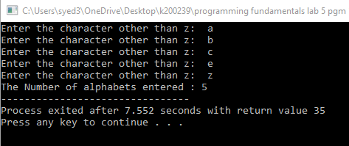

Question 3:

Write a program that generates and displays the first N three-digit odd numbers. Whereas

the number N is provided by the user.

Code:

#include<stdio.h>

int main()

{

int i=0,n=0,c=0;

printf("Enter the value of n : ");

scanf("%d",&n);

printf("First %d three digit odd numbers are : ",n);

for(i=100;i<=999;i++)

{

if(i%2!=0)

{

printf(" %d ",i);

c=c+1;

if(c==n)

break;

else if(i!=999)

printf(",");

}

}

}

Output:

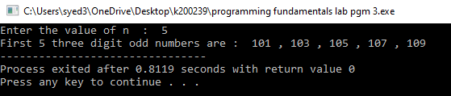

Question 4:

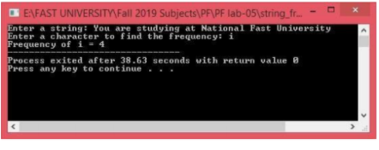

Code:

#include<stdio.h>

int main()

{

char a[100],ch;

int i=0,c=0;

printf("Enter a string : ");

gets(a);

printf("Enter a character whose frequency has to be calculated : ");

scanf(" %c",&ch);

for(i=0;a[i]!='\0';i++)

{

if(a[i]==ch)

c=c+1;

}

printf("Frequency of %c is %d",ch,c);

}

Output:

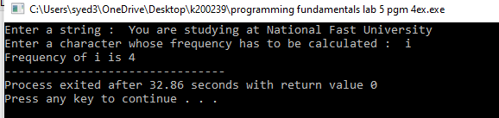

Question 5:

Write a program that asks user to input the starting number and ending number of the range.

The program should display the number of multiples of 5 in between that range.

Code:

#include<stdio.h>

int main()

{

int i=0,n=0,c=0,k=0;

printf("Enter the starting number : ");

scanf("%d",&i);

k=i;

printf("Enter the ending number : ");

scanf("%d",&n);

for(i;i<=n;i++)

{

if(i%5==0)

c=c+1;

}

printf("Multiples of 5 between %d and %d are %d",k,n,c);

}

Output:

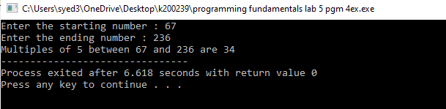

Question 6:

Write a program to print half pyramid using numbers.

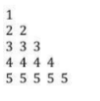

Code:

#include<stdio.h>

int main()

{

int i=0,j=0;

for(i=1;i<=5;i++)

{

for(j=1;j<=i;j++)

printf("%d ",i);

printf("\n");

}

}

Output:

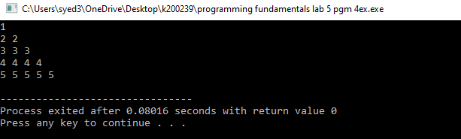

Question 7:

Write a program that takes two integers from the user (a base number and an exponent) and

calculates the power.

Code:

#include<stdio.h>

int main()

{

int num=0 ,exp=0;int i=1,a=1;

printf("Enter the base number : ");

scanf("%d",&num);

printf("Enter the exponent : ");

scanf("%d",&exp);

for(i=1;i<=exp;i++)

a=a\*num;

printf("Answer = %d",a);

}

Output :

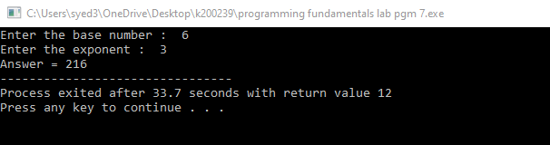

Question 8:

Write a program that uses break statement when value of variable becomes 88 and print

the statement that “Out of for loop”. Out should be like the displayed below.

Code:

#include<stdio.h>

int main()

{

int var;

for(var=100;var>=1;var--)

{

printf("var : %d\n",var);

if(var==88)

break;

}

printf("Out of for loop");

}

Output :

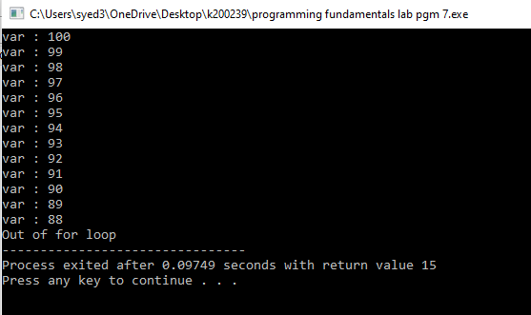

Question 9 :

Write a program to print following pattern.

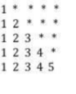

Code :

#include<stdio.h>

int main()

{

int i=0,j=0,k=0;

for(i=1;i<=5;i++)

{

for(j=1;j<=i;j++)

printf("%d",j);

for(k=4;k>=i;k--)

printf("\*");

printf("\n");

}

}

Output :

